Case Study on Hybrid Bypass

Routing of a traffic demand of the QLP utilising the Multi-hop Bypass approach

6/5/2025

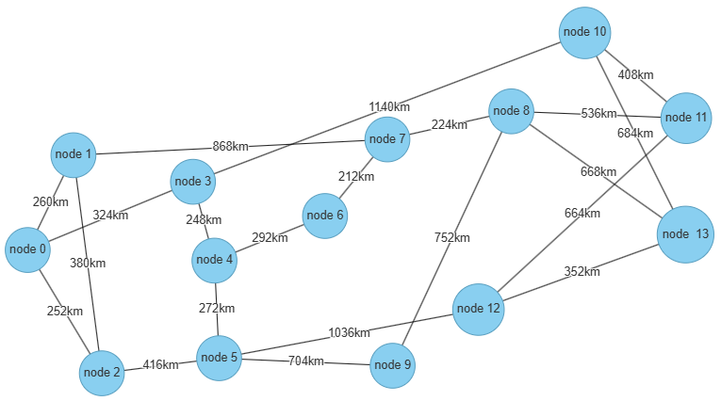

For the network NSFnet, mean traffic demand size X = 40 Gbps,

the routing of the traffic request 40 of the QLP over the virtual topology

|  |  |  |  |  |  |
| --- | --- | --- | --- | --- | --- |
| Step 222 | Processing queue 1 | request 39 | from Node9 (9) | to Node4 (4) | Remain 27.59 Gbps to be routed. |

for the assignment of virtual links (lightpaths) is realised by the Multi-hop Bypass algorithm and the request is routed utilising traffic grooming via the path on the virtual topology 5🡪0🡪1 consisting of the pre-existing virtual links [9, 13], [13, 7], [7, 0], [0, 5], [5, 4] hence the path on the virtual topology

node 9 🡪 node 13 🡪 node 7 🡪 node 0 🡪 node 5 🡪 node 4

During the routing of the virtual links over the physical topology and the assignment of wavelengths on the fiber links the Multi-hop Bypass algorithm considers **independently** each virtual link, finds the shortest path from the source to the destination of the virtual link and assigns wavelengths on the fibers of the corresponding physical links that constitute the shortest paths (note: we work on a wavelength converted WDM backbone network, so the wavelength continuity constraint does not apply).

This path is routed on the physical topology over the path

node 9 🡪 node8 🡪 node13 🡪 node8 🡪 node7 🡪 node6 🡪 node4 🡪 node3 🡪 node0 🡪 node2 🡪 node5 🡪 node4

This results to often revisiting nodes if we examine the physical path that the data traverse for the delivery of the traffic request data.

The reason is the fact that the Multi-hop Bypass does not examine the delivery of traffic per request.

Statistics for the run

182 TReq on the QHP

182 TReq on the QLP

103 TrGrm

35 physical paths with revisiting nodes